TIKEHAU Indicators
Content
1. Introduction 2
2. Decision Tree 3
3. Yield to maturity 4
4. Spread duration: TKO Cr Duration 5
5. Effective duration: TKO IR Duration 6
6. TKO Gearing 8
7. Annex functions 9

Introduction

Some analytics have been internally developed to match Front Office requirement
This document aims at describing the calculations that have been set up for the following indicators
- Effective duration: TKO IR Duration
- Spread Duration: TKO Cr Duration
- Yield To maturity: TKO YTM
The below formulae are calling standard Sophis indicators (YTM MtoM, Yield to call, yield to worst, Duration,). Those are documented in the Sophis financial documentation: Q:\Applications\sophis\LIVE\current\Documentation\docfi_AM_432.pdf

Remark:
The formulae to consolidate at portfolio/ fund level may differ from the formulae to consolidate at fund level in the various report. The consolidation formulae in the reports is explained in the reports section.

Decision Tree

All the following computations are based on the below decision tree
This decision tree indicates the expected reimbursement of the bond: Date to call, Date to worst or Maturity
We will call this function as it is used in other algorithms: TkocComputeTreeYTM

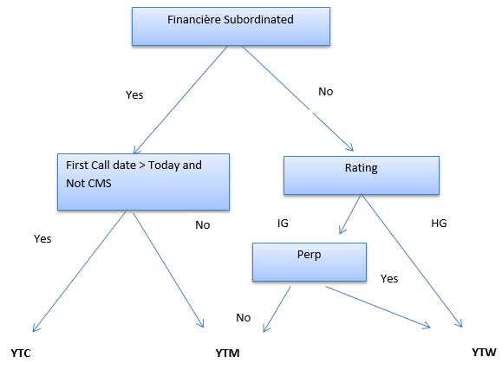
Algorithm as below:
IF: Research Sector = Financial AND Seniority = Subordinated (TestSeniority * = -1)
IF: Instrument type = Bond
IF: {Bond = floating AND Floating rate in (EUSA10 Curncy, EIISDA10 Curncy, TEC10 Index)}
IsCMS = True
ELSE IsCMS = False
IF: IsCMS = False && DateFirstCall> Today
Return 2 - YTC
Else
Return 1 - YTM
Else
Return 1 - YTM

ElseIF: Subordinated Not Financials OR seniority in (First lien, senior, Hybrid, Term Loan A, Term loan B/C, Second Lien, Mezzanine, PIK) (TestSeniority* = 1)
IF: Rating = Investment Grade **
IF: Perpetual (Maturity > 2048)
Return 3 - YTW
ELSE: Investment Grade
Return 4 - YTM
ELSE:
Return 3 - YTW
ELSE
Return 0: ERROR

Remarks:
* See in annex the calculation details to determine if a bond is Investment Grade, and the seniority calculation (function Test Seniority

Yield to maturity

The functions below depend on the yield to maturity calculation
The Column that displays this information is TKO YTM

At position level
IF: Instrument is a Bond or derivative (Type = O or D)
Tytm = 0
IF: Allotment = “Internal Securities”
Return TKO YTM = [YTM]
Tytm = ComputeTreeYTM
ELSE_IF: YTM: IG or CMS or First Call< Today (tytm = 1 or 4)
IF: [YTM MtM] < 15,
Return TKO YTM = [YTM MtM]
ELSE: Return TKO YTM = 15
ELSE_IF: YTC: Sub not CMS and FirstCall>Today (tytm = 2)
Return TKO YTM = MIN ([Yield to Call MtM], 15)
ELSE_IF: YTW: (tytm = 3)
Return TKO YTM = [Yield to worst MtM]
ELSE
Return TKO YTM = 0
ELSE_IF: Instrument is a CDS (Type = S)
Return TKO YTM = [YTM]
ELSE_IF: Instrument in an Interest Rate future (Type = F)
Return TKO YTM = [YTM]
ELSE_IF: Instrument is a Debt Instrument (Type = T)
Return TKO YTM = [YTM]
At portfolio level



At report level
Open ended funds & Mandats

Spread duration: TKO Cr Duration

The spread duration is an internally developed analytics
The column Name is [TKO Cr Duration]

At position level
Case1: Instrument type = Futures
TKO Cr Duration = Sophis Duration: Macaulay duration

Case2: All other Instrument types
TYTM = TkocComputeTreeYTM
Case 1: TYTM = 1 or 4: YTM
[TKO Cr Duration] = [Duration] (Macaulay duration)
Case 2: TYTM = 2: YTC
[TKO Cr Duration] = [Duration to Call MtM]
Case 3: TYTM = 3: YTW
[TKO Cr Duration] = [Duration to Worst MtM]
Case 4: TYTM = All other values
[TKO Cr Duration] = 0

At portfolio level

At report level
Open ended funds:
Column used: TKO Cr Duration Consolidate
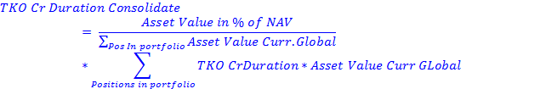
Mandats:

Effective duration: TKO IR Duration

The effective duration is an internally developed analytics
The column Name is [TKO IR Duration]

At position level:
IF: IR Future (Type = F)
Return TKO IR Duration = [Duration]
IF: CDS (Type = S)
Return TKO IR Duration = -Rho * Nominal
IF: Bond or Convertible (Type = O or D)
Compute DateWorkout from TkocComputeYTM (Maturity, Call, Worst)
Compute Yield from TkocComputeYTM (Yield to call MtM, Yield to worst MtM or YTM MtoM)
Compute InstrumentCreditType = GetCreditInstrumentType (Fixed, floating, fixed to float)
Return TKO IR DURATION = Compute Bond IR Duration (DateWorkout, Yield, InstrumentCreditType) (cf below)
ELSE:
Return TKO IR DURATION = 0

*******************************************************************************************
Compute Bond IR duration (DateWorkout, Yield, InstrumentCreditType)

IF: InstrumentCreditType = Fixed
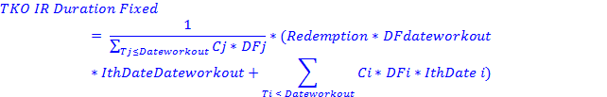
With:

Cj = Coupon Value @Tj * ActCpn
ActCpn = 1 by default except when Coupon date ≥ Dateworkout, in that case it is equal to FLOOR ((Nb Days Date workout to coupon)/ (Nb Days Start to end date)
DFj = Discount Factor at Tj computed as
=
IthDatei = Number of years from today to the Coupon i
= (DateCouponi-CalculationDate)/Basis

IF: InstrumentCreditType = Floating

IF: InstrumentCreditType = Fixed to float
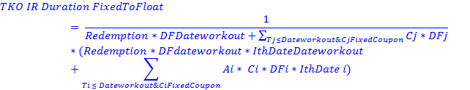
With:
Cj = Coupon Value @Tj :
Aj = 1 if Fixed, 0 If floating
DFj = Discount Factor at Tj computed as
=
IthDatei = Number of years from today to the Coupon i
= (DateCouponi-CalculationDate)/Basis
Yield = YTM determined by decision tree at Date workout
YTM MtoM: for all other cash flows
Remark:
1 - The yield used to discount the cash flows differs in the formulae between Fixed to float and fixed bonds: -> To be investigated
2 – The ratio ActCpn used in Fixed bond is not used here during the period for which the Date workout occurs: -> to be investigated

Portfolio level:
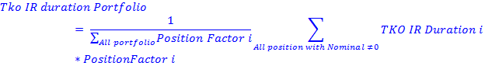
Where Position Factor i = Nominal If Future , else Asset Value

At report level
Open ended funds:
Mandats:

TKO Gearing

The Gearing is used to consolidate the sensitivities at portfolio level

At position level
Below are the formulae according to the asset class:
Instrument type | Sophis Type | TKO Gearing | Remark
Bond | O | Asset Value
Swap | S | ABS (Nominal) +Asset Value
Repo | P | Asset Value
Shares | A | Asset Value
Fund | Z | Asset Value
Index Futures | F | Delta Cash
Other Futures | F | Nominal
Cash & Fees | C | 0
Forex | E | 0
Debt Instruments | T | Asset Value
Options (index and shares) | D | ABS (delta cash)
Options listées (Dashboard | M | ABS (delta cash)
Convertible Bonds | D | Asset Value
Bond Future | F | Price of CTD * Contract Size * Number of Securities

All values are in EUR

At portfolio level

TKO Gearing Netting

This indicator is more secure comparing to the basic Gearing due to the delta cash sign.
Example: Buy 1000 Puts Strike170 and Sell 1000 Puts Strike160 on the same underlying.

Annex functions

Bond is investment grade if the Rating value is between 12 and 21
Rating | Value
AAA,Aaa,(P)Aaa | 21
AA+,Aa1 | 20
AA,Aa2 | 19
AA-,Aa3 | 18
A+,A1 | 17
A, A2 | 16
A-,A3 | 15
BBB+,Baa1 | 14
BBB, Baa2 | 13
BBB-,Baa3 | 12
BB+,Ba1 | 11
BB, Ba2 | 10
BB-,Ba3 | 9
B+,B1 | 8
B , B2 | 7
B-,B3 | 6
CCC+,Caa1 | 5
CCC, Caa2 | 4
CCC-,Caa3 | 3
CC, Ca1,Ca2 | 2
C,C1,C2,C3 | 1
R | 0
SD | 0
D | 0
else | null

Test seniority
2 parameters are taken into account:
Sector Research = Full Path ([Sector Tikehau Research Sectors])
(Example: Tikehau Research Sectors: Financials: Financials: Banks)
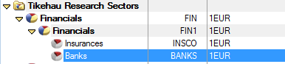

Seniority = Instrument seniority
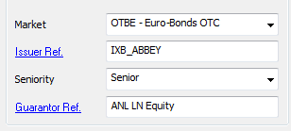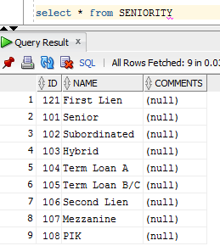

CASE 1: Seniority = Subordinated (Code 102) && Sector_Research Contains “Financials”
Return – 1 Financial subordinated
CASE 2: (Seniority = Subordinated (Code 102) && Sector_Research Does not Contain “Financials”)
OR
Seniority = First Lien (code 121)
OR
Seniority = Senior (code 101)
OR Seniority in {Hybrid, Term Loan A, Term loan B/C, Second Lien, Mezzanine, PIK} (102<Code<=109)
Return 1 – Sub Not financial OR First Lien OR Senior OR Hybrid/TL A/B/C OR 2nd Lien OR Mezzanine OR PIK
ELSE
Return 0

TkocComputeFixedOrFloat

CASE 1: Instrument type = Bond && Number of cash flows in the cash Flow explanation tab >= 2 && next coupon is Floating
Return 1
ELSE
Return 0

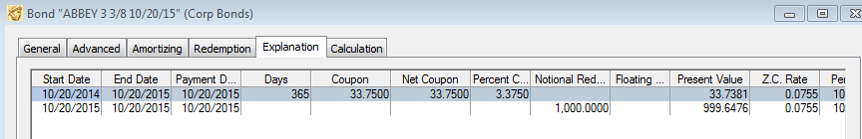

GetCreditInstrumentType
CASE 1: Bond (Type = O)
IF: Future cash flow only fixed
InstrumentType = 1 – Fixed
IF: Future Cash Flow only Floating
InstrumentType = 2 – Floating
IF: Futures cash flows Contain Fixed and Floating
InstrumentType = 3 – Fixed To Float
IF: REDEMPTION, FLOATING SWAP ET CAPITAL FLOW (Aucun cas identifié en portefeuille)
Nothing Done
CASE 2: Convertible Bonds (Type = D && Allotment = ‘Convertible’)
IF: Future cash flow only fixed
InstrumentType = 1 – Fixed
IF: Future Cash Flow only Floating
InstrumentType = 2 – Floating
IF: Futures cash flows Contain Fixed and Floating
InstrumentType = 3 – Fixed To Float
IF: REDEMPTION, FLOATING SWAP ET CAPITAL FLOW (Aucun cas identifié en portefeuille)
Nothing Done
CASE 3: CDS (Type = S)
InstrumentType = 4 - CDS
ELSE: All other types
InstrumentType = 0 – Others
Return InstrumetnType

